Device Name: Microsoft - Surface Book 2

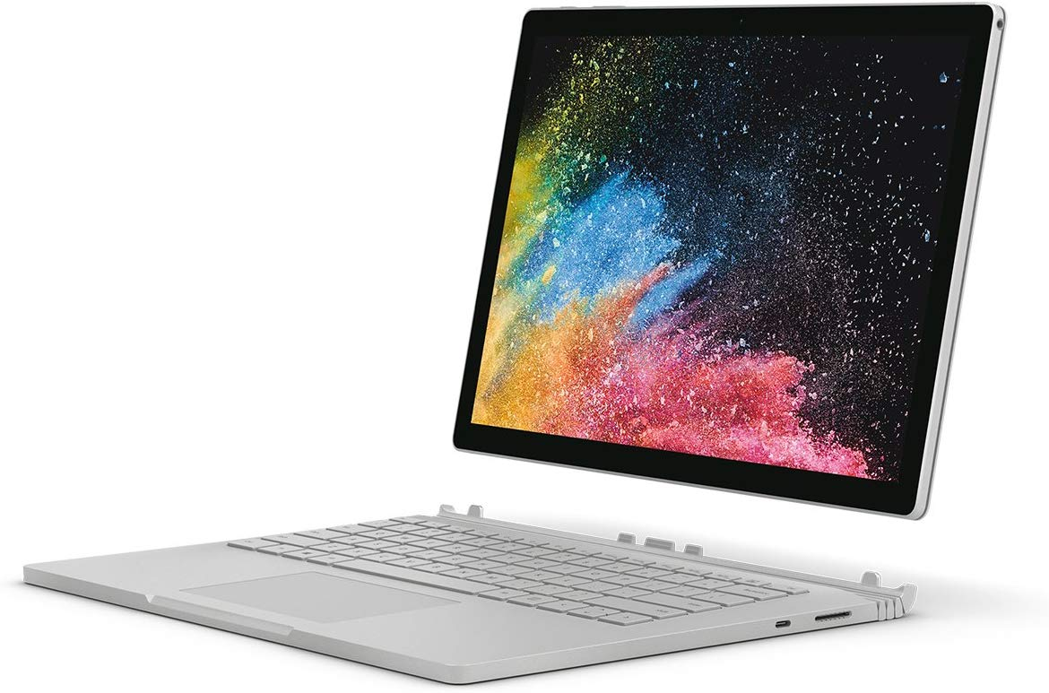

Price: $2300

**SPECIFICATIONS:**

|  |  |
| --- | --- |
| Processor: | Intel Core i7-8650U (1.9 GHz) |
| Memory: | 16 GB DDR3 |
| Storage: | 500 GB |
| Screen Size: | 13.5 |